Smart Borewell Monitoring System Using IoT and Dashboard Monitoring

Abstract
Groundwater is an important water source for agriculture and domestic use in many regions such as India and Pakistan. However, many borewell systems operate without monitoring, which leads to pump damage, dry-run conditions, water wastage, and energy loss.
This project proposes a smart IoT-based borewell monitoring system that continuously monitors pump conditions and water levels. Sensors collect real-time data such as pump sound pattern, temperature, humidity, and tank water level. The data is directly processed by the Raspberry Pi and continuously updated to the real-time dashboard for monitoring.
The system helps detect abnormal pump conditions, prevent dry-run operation, and provide alerts to users through the dashboard and MQTT mobile notifications. This solution improves water management, reduces electricity consumption, and increases pump lifespan.

Problem Statement
Farmers and water management authorities face difficulties in monitoring borewell pumps and groundwater usage. Most borewells operate manually without any intelligent monitoring system. This results in several problems:
• Pumps running without water (dry run)
• Sudden borewell failure
• Motor overheating and damage
• Excessive electricity consumption
• Lack of groundwater usage data

A smart monitoring system is required to track borewell health, detect abnormal conditions, and provide real-time alerts to improve water management and pump efficiency.

Objectives
• Design an IoT-based system for monitoring borewell pump conditions.
• Measure water level and pump parameters in real time.
• Detect dry-run conditions and pump overheating.
• Send alerts and notifications to users.
• Continuously display and monitor sensor data on the dashboard.
• Improve water efficiency and reduce electricity consumption.

Architecture Diagram (Concept)
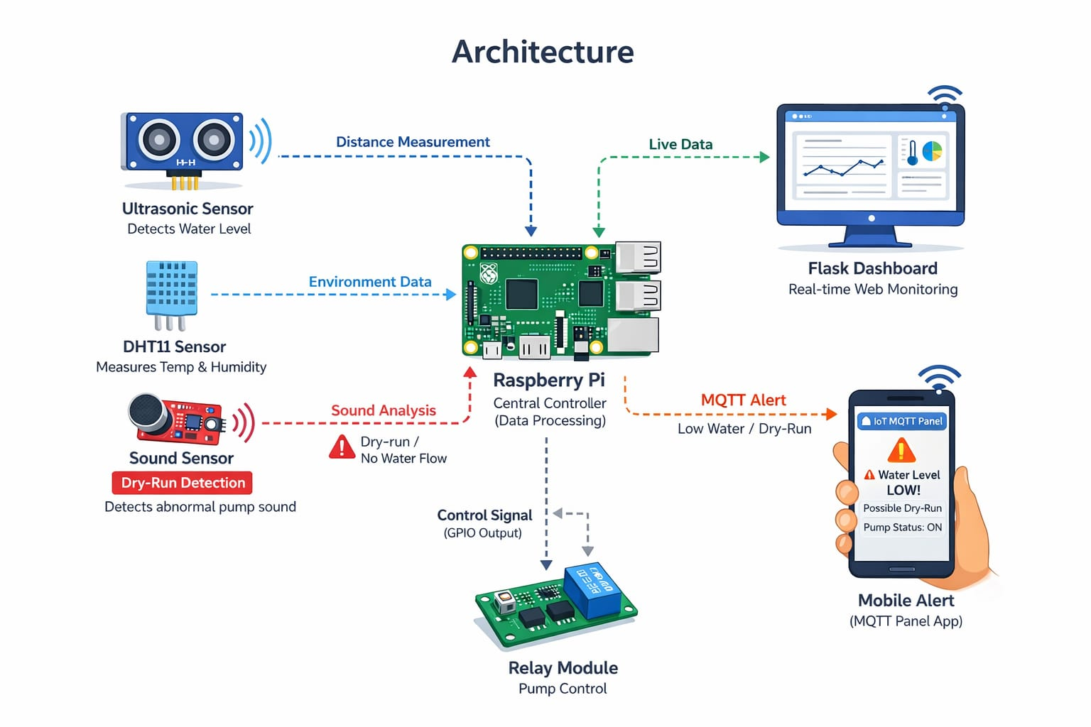

Technologies Used
Hardware:
• Raspberry Pi
• Ultrasonic Sensor
• DHT11 Sensor
• Sound/Vibration Sensor
• Relay Module

Software:
• Python on Raspberry Pi
• MQTT Protocol
• Flask Dashboard for Real-time Monitoring
• Dashboard for Monitoring

Programming Languages:
• Python
• HTML / CSS / Python

Implementation (Git)
The project code and documentation are maintained using Git version control.
Repository includes:
• Sensor data collection code.
• Raspberry Pi sensor and control scripts.
• Dashboard data update and continuous monitoring scripts.
• MQTT mobile alert configuration.

Workflow:
Hardware Setup → Sensor Data Collection → Raspberry Pi Processing → Dashboard Update → MQTT Alert Notification

Results / Output
The implemented system successfully:
• Monitors tank water level.
• Detects pump temperature and vibration.
• Continuously updates and displays sensor readings on the dashboard.
• Displays pump and water status on a dashboard.
• Generates alerts when abnormal conditions occur.

Example alerts:
• Low water level alert.
• Pump overheating warning.
• Dry-run detection notification.

Challenges Faced
• Sensor calibration and accuracy issues.
• Maintaining stable internet connectivity.
• Dashboard integration and real-time update handling.
• Power supply management.
• Debugging communication errors between sensors and Raspberry Pi.

Future Improvements
• Add machine learning for predictive borewell failure detection.
• Develop a dedicated mobile application.
• Use solar power for remote borewell locations.
• Expand monitoring to multiple borewells.
• Integrate advanced analytics into the dashboard platform.

